|  |
| --- |
| Date/Location |
| 03/01/2022 @Zoom |

|  |  |
| --- | --- |
| Attendees | |
| Client | MAVDEV |
| Joe Saceric | Ammar Lokhandwala |
| Umera Khan | Maria Frausto |
|  | Michael Gurch |
|  | Victoria Sheraden |
|  | Vivian Bui |

|  |
| --- |
| Meeting Agenda |

1. **Current Trello Board**

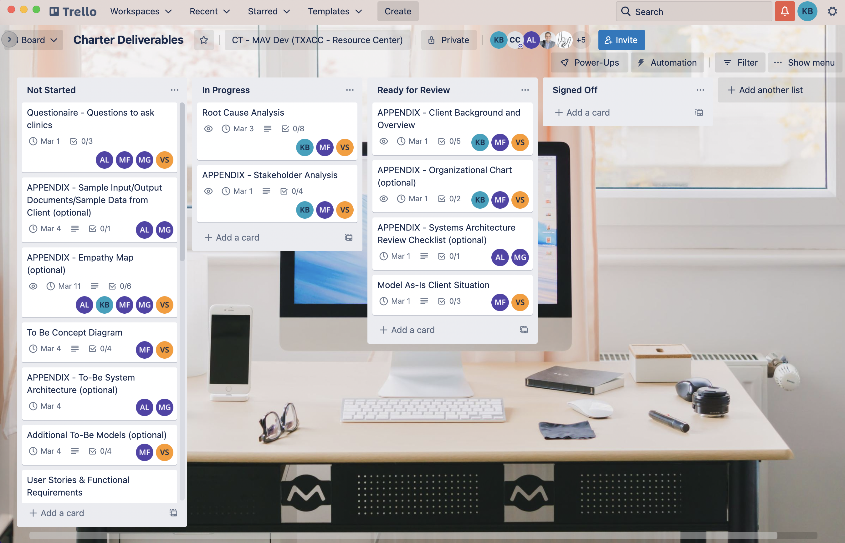

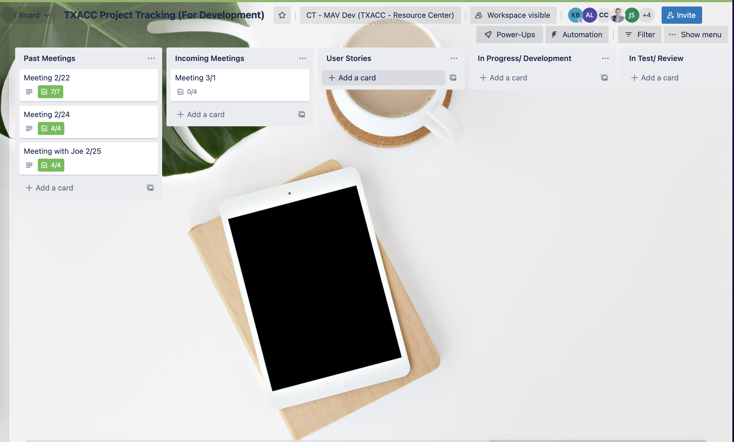

1. **Discussion Agenda**
2. Review Stakeholder Analysis Rough Draft
3. Review Root Cause Analysis Rough Draft
4. Review Questionnaire List for Clinics to Interview
5. Sign-off Trello Board
6. **Project Tracking**

* Project Tracking (For Meetings and Development)

<https://trello.com/b/r8DXAHG0>

* For Charter Deliverables

<https://trello.com/b/sucG4Wpv>